Acoustics Lab Two Report
2/27/2025

Caleb Young
Department of Science and Engineering
University of Central Arkansas
Conway AR, United State of America
cyoung24@cub.uca.edu

Abstract:

This lab demonstrates “non-destructive” testing. The objective is to determine the physical characteristics of a speaker, i.e. effective mass and stiffness, using its measured resonance frequencies in different cases.

Table of Contents:

- Introduction

- Theory

- Experimental Procedure

- Results

- Discussion

- Conclusions

- References

- Introduction:

The objective of this lab is to characterize the mechanical properties and physical characteristics of a speaker and its enclosure. This lab is based upon a Freshman Year Experience course at Penn State University.

Equipment List & Setup:

Item | Quantity
speaker | 1
speaker box | 1
frequency generator | 1
multimeter & probes | 1
100Ω resistor | 1
digital oscilloscope | 1
electronic switching box | 1
5-gram masses | 6

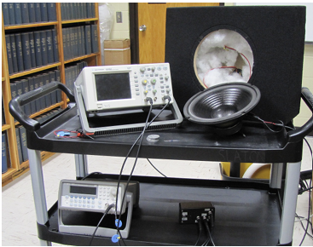
- Theory:

- Background:

A speaker is a beautiful electromechanical system. Magnetic force is exerted when AC current f lows through a coil of wire in a magnetic field. The coil is attached to a paper cone which is connected to a flexible surround and finally to the speaker frame. The flexible surround has a spring constant and the wire coil plus cone has a mass so you can imagine there will be a resonance frequency for the system in addition to mechanical damping. The first part of this lab will be devoted to finding this resonance frequency and the second to determining the mechanical damping.

We don’t want to destroy the speaker to determine the mass of the coil, the suspension’s spring constant or the mechanical resistance of the system. These values are important for modeling the speaker’s performance in a speaker box (which has its own acoustic properties!), experiment or audio environment. Additionally, the measurement of these values on a production line gives a means of on-the-spot quality control and testing. The method we will employ in this lab is generally called non-destructive testing.

- Effective Mass & Stiffness:
We can be clever and note that for a simple mass and spring we have the relationship,
$Type equation here.$ ,
where s is the effective spring constant of the speaker and m0 is its effective mass. We can easily change the effective mass of the system by adding mass to the dome of the speaker. This would result in a new resonance frequency. Hence,
$Type equation here.$ ,
This can be rearranged and solved for the period-squared,
$Type equation here.$ ,
which looks like the equation for a straight line with slope equal to 1/s and y-intercept equal to m0/s. Thus, by determining the resonance frequencies for the system with various added masses we can determine the unknown effective mass, m0, and the effective stiffness (spring constant), s.

- Mechanical Resistance:
To determine the mechanical resistance of the speaker, measurements of its decaying oscillations as a function of time need to be made. These oscillations are measured by the oscilloscope hooked up to the speaker’s voice coil. As the voice coil moves in the gap between the poles of the speaker’s magnet a voltage is induced due to Faraday’s Law. The oscilloscope records this voltage on its screen.

- Experimental Procedure:

A speaker with a 10-inch diameter is to be tested as well as its closed speaker box. The 100 Ohm current limiting resistor should be used with the speaker during the resonance frequency tests to avoid damage to the voice coil. This resistor may be removed during the free decay procedure.

- Effective Mass & Stiffness Procedure:
- Starting with the frequency generator set to 30Hz. Adjust the frequency until the amplitude of the sinusoidal wave is at a maximum voltage peak.
- Record this frequency and the mass added to the speaker. The mass will start at 0g and go up to 30g.
- Decrease the frequency and add 5g to the center of the speaker’s dome. Find the resonance frequency again when the wave is at a maximum voltage peak. Observe and document the response.
- Repeat this process until the 30g mass added resonance frequency has been recorded.
- Repeat steps 1 – 4 for the speaker when it is in the box with no stuffing inside as well as when it is in the box with stuffing. Recording this in a .csv file for plotting is a good idea.

- Mechanical Resistance/ Free Decay Procedure:
Remove the speaker from the box and set the frequency generator to the resonance frequency for the speaker with no mass added. Set up the circuitry mentioned above (no resistor is required). To acquire a single free-decay waveform, the o-scope has to trigger on the signal from the switch box.

- Press the “Mode/Coupling” button, then use the ”soft keys” to the right of the display to choose the following options. Mode→Sweep, Coupling→DC, triggering source→External.
- Use the “Horizontal” knob to increase the sweep time to 20 msec/div so that more of the exponentially decaying waveform will be displayed.

- Plotting Data Procedure:
- Using the data collected from the Effective Mass & Stiffness Procedure, plots should be made using the period squared calculations. From the slope and y-intercepts the effective mass and spring constant (stiffness) can be found.
- Using the data collected from the Mechanical Resistance/ Free Decay Procedure, plots should be made where the best fit line through time vs the natural log of the recorded voltage yields the magnetic field. This can be used to calculate the mechanical resistance through the use of: $Type equation here.$

- Results:
Note: I made the mistake of physically writing down experiment results on paper. This caused me to waste a fair amount of time copying it into .csv files when the data should have just been recorded in them while carrying out the experiment. Please learn from this mistake of mine.

The image shown below are the on-paper resulting measurements made:
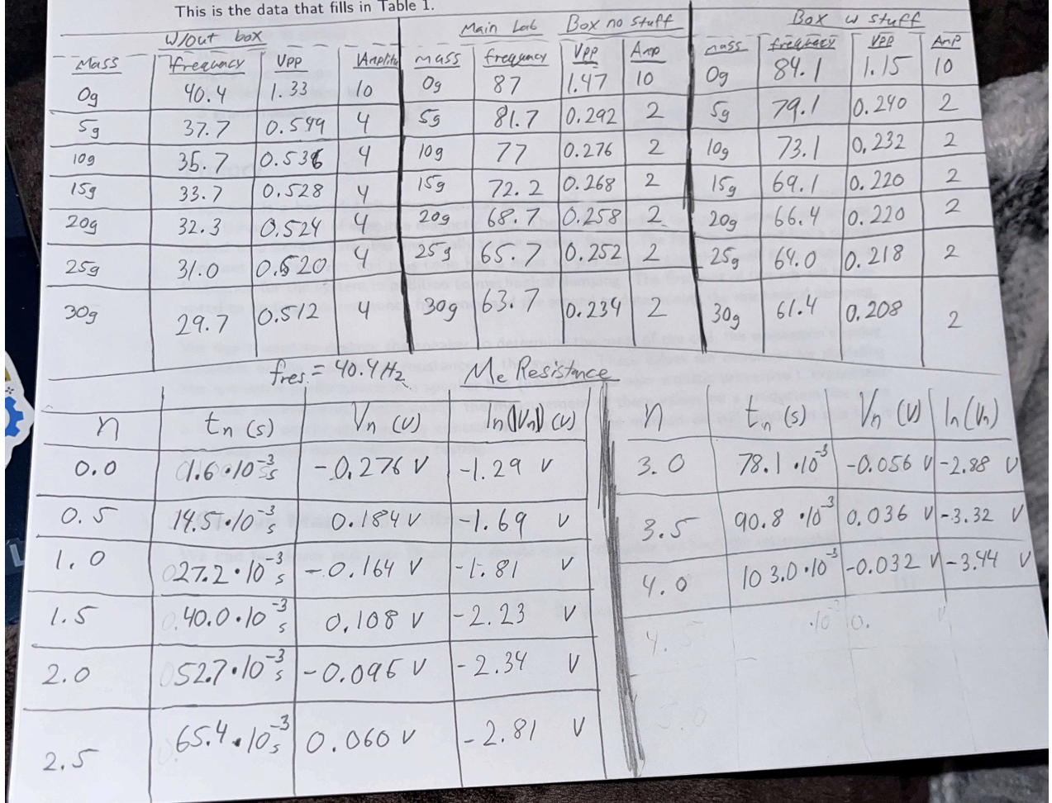

- Effective Mass & Stiffness Results:
After copying data to .csv files I was able to create a jupyter notebook in Visual Studio Code for the job of plotting data and performing calculations. I described my experiment to the CoPilot assistant in VSCode and used the Claude Sonnet 4.5 model for it. Once the experiment was stated clearly I gave the .csv files to it and it wrote the code to create detailed plots of my data. In addition to this, I also gave it the necessary theory and equations to use and it wrote the code to calculate the effective mass and spring constant for the speaker.

- The first piece of code for this did not plot. It only did calculations. Results/ output of this are shown below:
Speaker Without Box:
- Slope: 0.017220 ± 0.000169 s²/kg
- Intercept: 0.000615 s²
- R²: 0.999521
- Spring constant s: 2292.56 ± 22.44 N/m
- Effective mass m₀: 35.72 ± 1.79 g
- Resonance freq f₀: 40.32 Hz
Speaker in Box (No Stuffing):
- Slope: 0.003928 ± 0.000083 s²/kg
- Intercept: 0.000131 s²
- R²: 0.997769
- Spring constant s: 10050.73 ± 212.53 N/m
- Effective mass m₀: 33.46 ± 1.67 g
- Resonance freq f₀: 87.23 Hz
Speaker in Box (With Stuffing):
- Slope: 0.004142 ± 0.000124 s²/kg
- Intercept: 0.000143 s²
- R²: 0.995537
- Spring constant s: 9530.82 ± 285.37 N/m
- Effective mass m₀: 34.46 ± 1.72 g
- Resonance freq f₀: 83.71 Hz
- The plot of this graph came out nicely, but I could not figure out the error bars. The plot of added mass vs. the period squared data is shown below:

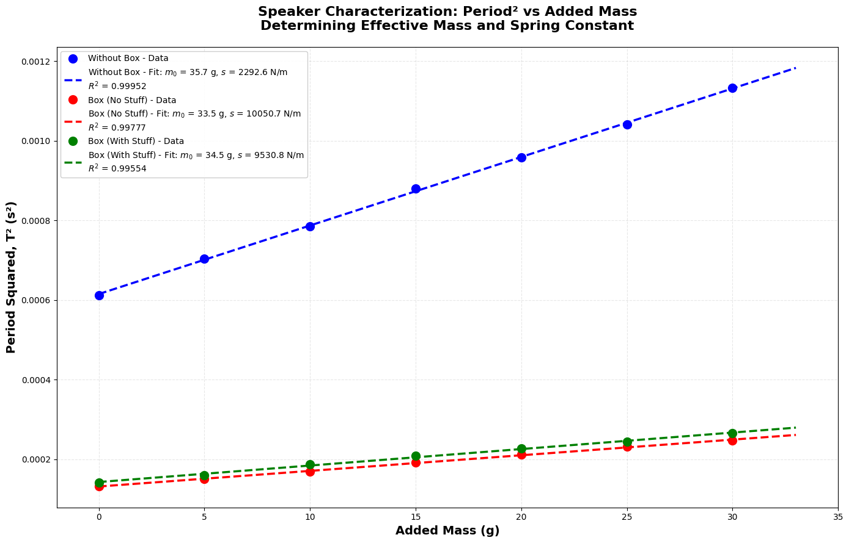

- Copilot did something very interesting without me explicitly stating to do so. It also calculated and displayed a comparison of configurations as well as a physical interpretation. These results are displayed below:

======================================================================
COMPARISON OF CONFIGURATIONS:
======================================================================
Configuration: f₀ (Hz) m₀ (g) s (N/m) R²

Speaker Without Box: 40.32 35.72 ± 1.79 2292.56 ± 22.44 0.999521

Speaker Box (No Stuffing): 87.23 33.46 ± 1.67 10050.73 ± 212.53 0.997769

Speaker Box (With Stuffing): 83.71 34.46 ± 1.72 9530.82 ± 285.37 0.995537
======================================================================

======================================================================
PHYSICAL INTERPRETATION:
======================================================================
• Speaker Without Box: f₀ = 40.3 Hz (lowest resonance)

• Speaker Box (No Stuffing): f₀ = 87.2 Hz (highest resonance)

• Speaker Box (With Stuffing): f₀ = 83.7 Hz (intermediate)

Box effect: Increases stiffness by 338.4%

Stuffing effect: Reduces stiffness by 5.2% vs empty box

- Mechanical Resistance Results:
Again, I had to copy the data from this experiment over to a .csv file. The results of this part are similar to the results above.

- The first code for this part of the experiment yielded just calculations like the last one. Results of this are displayed below:
=====================================================================
LAB 2: MECHANICAL RESISTANCE FROM FREE DECAY
=====================================================================
Free Decay Data:
n time (s) voltage (V) ln |V|
0.0 0.0016 -0.276 -1.29
0.5 0.0195 0.184 -1.69
1.0 0.0272 -0.164 -1.81
1.5 0.0400 0.108 -2.23
2.0 0.0527 -0.046 -2.34
2.5 0.0654 0.060 -2.81
3.0 0.0781 -0.058 -2.88
3.5 0.0908 0.036 -3.32
4.0 0.1030 -0.032 -3.44
=====================================================================
MECHANICAL RESISTANCE RESULTS:
=====================================================================
Linear fit: ln(|V|) = -1.269 - 21.71*t
R² (goodness of fit): 0.988962
Damping coefficient β: 21.71 ± 0.87 s⁻¹
Time constant τ: 46.06 ± 1.84 ms
Mechanical resistance R_m: 1.5512 ± 0.0619 kg/s
Quality factor Q: 5.83
Using m₀ = 35.72 g (from 'Without Box' measurement)
=====================================================================

- Copilot created two plots for these results. The first being the oscillations of free decay with voltage over time. The second being an analysis of this. See the images below:
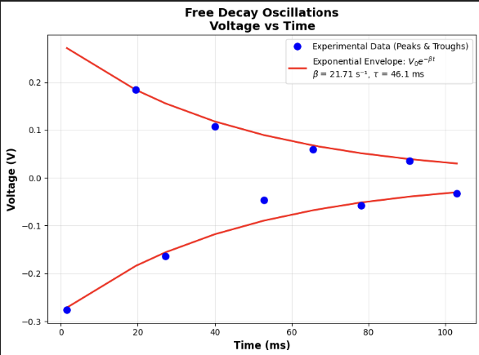
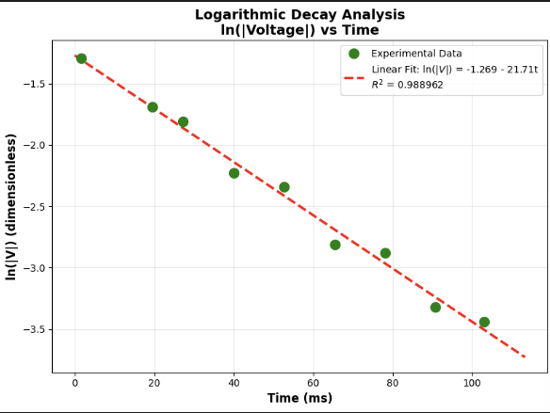
- Overall Results:
CoPilot impressed me with this code and analysis. I did not tell it to perform this, but it went above and beyond. The below information is some repeated results, but it helps to summarize the results all in one place. See the code output below:

LAB 2: COMPLETE SPEAKER CHARACTERIZATION SUMMARY

PART 1: Effective Mass and Spring Constant
----------------------------------------------------------------------
Without Box:
Resonance frequency f₀: 40.32 Hz
Effective mass m₀: 35.72 g
Spring constant s: 2292.56 N/m

Box (No Stuff):
Resonance frequency f₀: 87.23 Hz
Effective mass m₀: 33.46 g
Spring constant s: 10050.73 N/m

Box (With Stuff):
Resonance frequency f₀: 83.71 Hz
Effective mass m₀: 34.46 g
Spring constant s: 9530.82 N/m

----------------------------------------------------------------------------------------------------------------------------------
PART 2: Mechanical Damping (Without Box)
----------------------------------------------------------------------------------------------------------------------------------
Damping coefficient β: 21.71 s⁻¹
Mechanical resistance: 1.5512 kg/s
Time constant τ: 46.1 ms
Quality factor Q: 5.83

======================================================================
PHYSICAL INSIGHTS:
======================================================================
1. Box Effect on Resonance:
- Adding a box increases resonance from 40.3 Hz to 87.2 Hz
- This is due to air spring inside the box adding stiffness

2. Stuffing Effect:
- Stuffing reduces resonance to 83.7 Hz
- Absorbs sound energy, effectively softening the air spring

3. Damping:
- Time constant of 46.1 ms means amplitude decays to 37% in this time
- Q-factor of 5.8 indicates overdamped system

- Discussion:

- Effective Mass and Stiffness:
The results of this part of the lab were satisfactory to my standard. However, I believe I have much to learn on this subject. Studying electricity and magnetism dynamics at the same time as taking this acoustics class helps me to visualize what is going on in the speaker down to the level of electric and magnetic interactions. Combining this with the study of acoustics helps to understand the big picture of speakers overall. As was stated in the beginning of this report, “A speaker is a beautiful electromechanical system”.
This part of the experiment was not hard to complete and is a really fun way to gain understanding of the cross overs between electromagnetism and acoustics.

- Mechanical Resistance:
Again, the results of this part of the lab was satisfactory. After plenty of practice collecting data in the first part, using the o-scope became easy.

- AI-Usage:
The usage of CoPilot inside of VSCode is great. Parts of this lab in my opinion need to be done with your own personal knowledge and reasoning skills. It is important to do this during experimentation as understanding where human error occurs or could happen plays a huge role in experimentation in all areas of study. Now once you’ve collected good sufficient data and know where faults might lie, I believe it is totally reasonable to use AI in creating graphs and summarizing data. Make sure to review its results as I had to correct a few things in mine.

- Conclusions:

From the results of this experiment I see why speakers get put in boxes not only for protection, but also for the physical additions they add to the sound. Without a box the speaker has to perform more work to output a larger sound. It also helps with the oscillations of the speaker that would cause rattling. A higher resonance frequency will also help to draw out more of the bass sounds that are hard to hear around 40Hz. This will of course depend on the material, size, shape, and stuffing inside of the box.

The air inside of the box acts as a spring due to the oscillations of the speaker. This adds stiffness to the overall system. Now without stuffing its good, but adding stuffing helps to absorb any sound inside of the box that could mess with the sound quality. You could say the stuffing dampens the air spring.

The second part of this lab helps to dive deeper into the concepts above. The Q-factor of 5.8 indicates that the system is overdamped. This means that any extra sound or noise that would cause undesired sound quality is handled already by the speaker design. With the addition of the box and stuffing this effect is improved.

Overall, this was a fun lab and gives insights to things that I like to study in my free time. I love music and playing guitar and designing a system for myself is a goal I have for the future.

- References:

Note: I need help with proper referencing

[1] “Lab 2: Speaker Characterization”, Dr. Slaton Ph.D., 2026

[2] CoPilot in VSCode, Creating plots and calculations.

